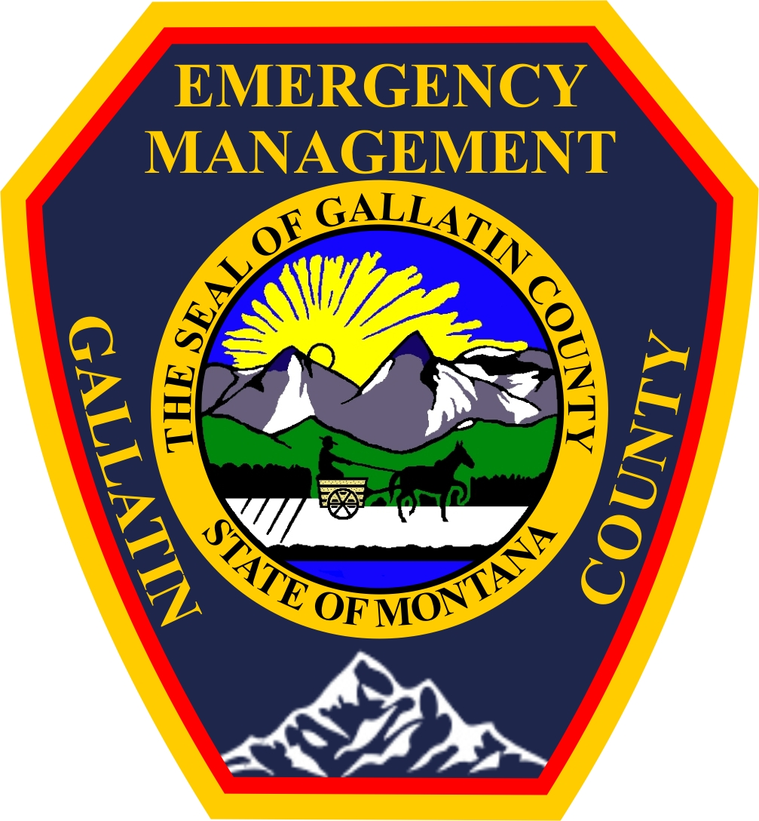
Gallatin County Multi Agency
DAILY TIME REPORT
(to be completed by everyone working on the Incident,
including volunteers, for EACH day worked on Incident)

Name: Personnel Number: __________________________
Agency: ______________________ Incident Name: ____________________________
Incident Number: ____________________________
Date:

Shift ________ --- __________ Mileage (Odometer or Hour reading)
Ending: __________________
OT _________--- __________ Starting: __________________
Total miles driven: ______________
TOTAL HRS.______________ Vehicle used:
Agency Personal
OVERTIME HRS._____________ Vehicle year/make: ____________
Travel time ___________ Vehicle license: ____________
(If not paid for it)

TOTAL Incident Time _________
(If your detail time was split up
between several activities, break
down the time spent on each
activity and list below.)

This information is required. List the activity, location as applicable, and the amount of hours spent on the activity. (Please be very specific)

Individual’s Signature: _______________________________________

*******This slip must be filled out completely each day*******

Submit original to your agency. Send copy to time@gcem.us or fax to (406) 548-0139

